

|  |  |  |  |  |  |  |  |  |
| --- | --- | --- | --- | --- | --- | --- | --- | --- |
| **Artifact Information** | | | | | | | | |
| **Artifact ID** | | **Artifact Title** | | | | | | |
| SOS-001 | | Software Overall Summary | | | | | | |
| **Capstone Team** | | | | | **Revision** | | **Artifact Date** | |
| Capstone Team 27 - Granustem | | | | | 1.1 | | Mar 01, 2019 | |
| **Prepared by** | | | | | **Checked by** | | | |
| Jonathan Meldrum | | | | | Tanner Gaskin | | | |
| **Revision History** | | | | | | | | |
| **Revision #** | **Date** | | **Prepared by** | **Checked by** | | **Description** | | **Approved by** |
| 1.0 | Feb 10, 2019 | | Jonathan Meldrum | Tanner Gaskin | | Initial Version | | Reese Bastian |
| 1.1 | Mar 01, 2019 | | Jonathan Meldrum | Tanner Gaskin | | Added references to Software Documentation and Source Code artifacts | | Reese Bastian |

1. Purpose

This artifact describes the organization of the software.

2. Subsystem Summary

The software subsystem uses Kivy, a cross-platform GUI framework, to create views that the user can interact with. The Presenter section communicates with the Model through events. The model interacts with peripherals through I2C, SPI and GPIO.

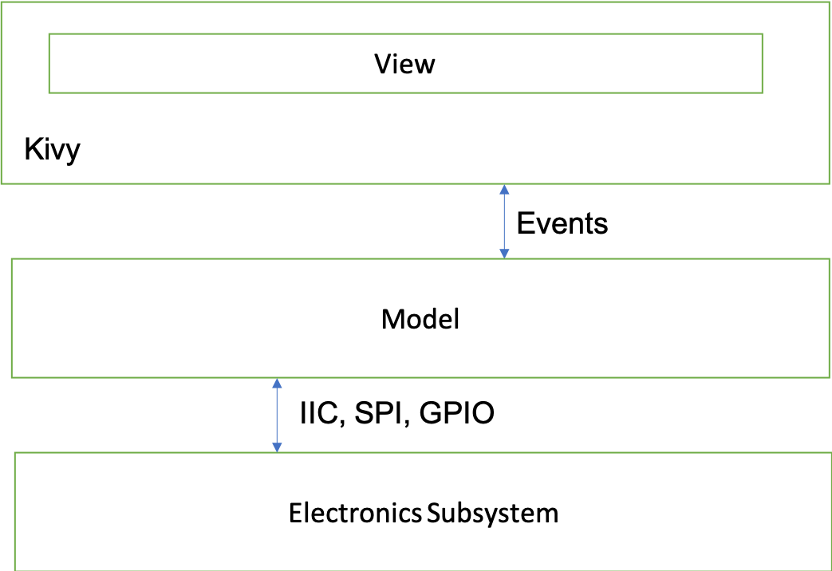

3. Kivy

Previous capstone teams have already built software that we have based our design on. To create their GUI, they drew boxes using the pygame library. Our software, however, needs to support a touchscreen. Rather than use their software, which would need to be heavily modified by adding touch-detection code for each “button” (box), we decided to port the software to Kivy, which already has touch-detection code and greatly simplifies the user interface portion of the program. Kivy generates events which instruct the model to generate data.

4. Communication with Electrical Subsystem

The software communicates with the sensors through GPIO and I2C. We also support SPI, so that additional devices can be added later. The Raspberry Pi comes with software to handle the communication protocols for us. For more information, see:

* I2C: <https://www.nxp.com/docs/en/user-guide/UM10204.pdf>
* GPIO: <https://www.raspberrypi.org/documentation/usage/gpio/python/README.md>
* SPI: <https://www.intel.com/content/dam/support/us/en/documents/software/chipset-software/327432-004_espi_base_specification_rev1.0.pdf>

5. Documentation and Source Code

Project documentation is contained in Artifact SD-001. Source code is in Artifact SRC-001.